[1/6/2023]

PROJECT PROPOSAL

Rescue Car

Mustafa Shusha 19102675
Younes Ahmed 19102463
Mahmoud Awad 19101863

I. Summary 3
II. Introduction 4
III. Needs/Problems 5
IV. Goals/Objectives 6
V. Procedures/Scope of Work 6
VI. Timetable 10
VII. Budget 11
VIII. Key Personnel 12
IX. Evaluation 13
X. Endorsements 14
XI. Next Steps 15
XII. Appendix 15

- Summary

On a summation we can provide these information, The rescue car is developed for a non-human tele-missions which can be performed on a mild distance without human interference and collect priceful data needed to make a detailed report about the mission. It is a car that has 4++ sensors that can detect many things such as the distance between it and the obstacle in front of it or behind it, if someone is moving beside it and also if the place of the mission is dark or not and can provide some data on any gas leakage, can be controlled by a PS4 controller which has a Bluetooth transmitter, and the car has the receiver part to make it easier for the user to control it and a camera that takes a photoshoot for more details. The main purpose of making this car is for just protecting the human factor for the beginning part of the rescue mission, we can just send the car to the mission location, collect some information and act on its information then we can send the human team to the rescue location to not waste any men power.
The end result is incredibly helpful because the car is faster than any human, can squeeze in any tiny spot of the location and can detect almost every motion near it. The anticipated budget may be from 2000 to 3000 EGP based on the inflation prices and the quality of the equipment used. It is just a prototype and can be used as a template for bigger projects and can add some other parts on it to make it more professional and convincing for the rescue department.

- Introduction
In the domain of emergency response and disaster management, the prompt and effective deployment of interventions remains of paramount importance. Remote-controlled (RC) vehicles have emerged as a promising solution for accessing inaccessible areas and providing vital aid during crises. This report explores the revolutionary Rescue RC Car, an adaptable miniature robotic vehicle furnished with four intelligent sensors - ultrasonic, LDR, IR, and MQ2 smoke sensors. With its compatibility with a PlayStation 4 (PS4) controller and an integrated camera system capturing real-time screenshots, the Rescue RC Car exhibits an extensive array of capabilities. Furthermore, it offers substantial benefits to a diverse range of stakeholders involved in emergency scenarios.
The utilization of the Rescue RC Car extends to various entities engaged in emergency response and disaster management. First and foremost, first responders including police, firefighters, and paramedics can greatly benefit from the RC car's assistance in navigating treacherous environments, collecting crucial information, and assessing situations remotely, thereby minimizing risks to human personnel. Additionally, search and rescue teams tasked with navigating challenging terrains, collapsed structures, or hazardous surroundings can effectively employ the Rescue RC Car to access tight spaces, explore unstable areas, and provide visual and sensor data that facilitate their operations.
Emergency management agencies heavily rely on accurate, real-time information to make informed decisions during disaster situations. The deployment of the Rescue RC Car enables these agencies to gather essential data on factors such as smoke levels, structural integrity, and potential hazards. Such insights significantly aid in efficient disaster response and optimal resource allocation.
The military and defense sectors can also harness the potential of the Rescue RC Car for reconnaissance purposes. The RC car's abilities to collect intelligence in complex urban environments, remote locations, and situations involving potential threats or unexploded ordnance empower military and defense units to gather critical information from a safe distance.
In conclusion, the multifunctional Rescue RC Car holds immense potential for a diverse range of users, including first responders, search and rescue teams, emergency management agencies, military and defense units, research institutions and more. Its deployment within these contexts can greatly enhance operational efficiency, heighten situational awareness, and ultimately contribute to saving lives
- Needs/Problems
Before we can initialize or begin the projects, first we must identify the needs for making a car like this and what will be the problems that we will be facing.
- We can see that we want a car that can enter and squeeze itself into any tiny hole, that implies that we need a car body that is not bigger that approximately 20 cm width and 30 to 40 cm length
- We want a car that can move on almost any surface which gives us a picture of the tires of the car, it must be thick, has a huge surface area and can drive through any obstacle against it, like that we also need that the body of the car must have a light weight.
- It has many sensors attached to it and as a conclusion it needs a power source powerful enough to charge all these components at the same time, it can be a low voltage high-amperage to make the car run for the most time possible, thus it was a problem before that the car looses to its power in the middle of the mission and as a conclusion we lost the car and we lost all the information that comes with the car and at last it extends the time of the mission though the time is the most critical part !
- The car can detect gas leakage and fire, but it cannot withstand the fire as the body may crumble, so we can add a body with a tougher material but as said before it depends on the quality of the material and the budget as seen in the next photos ( 1 and 2 )
- 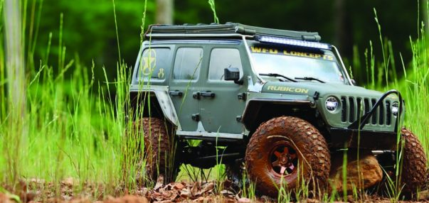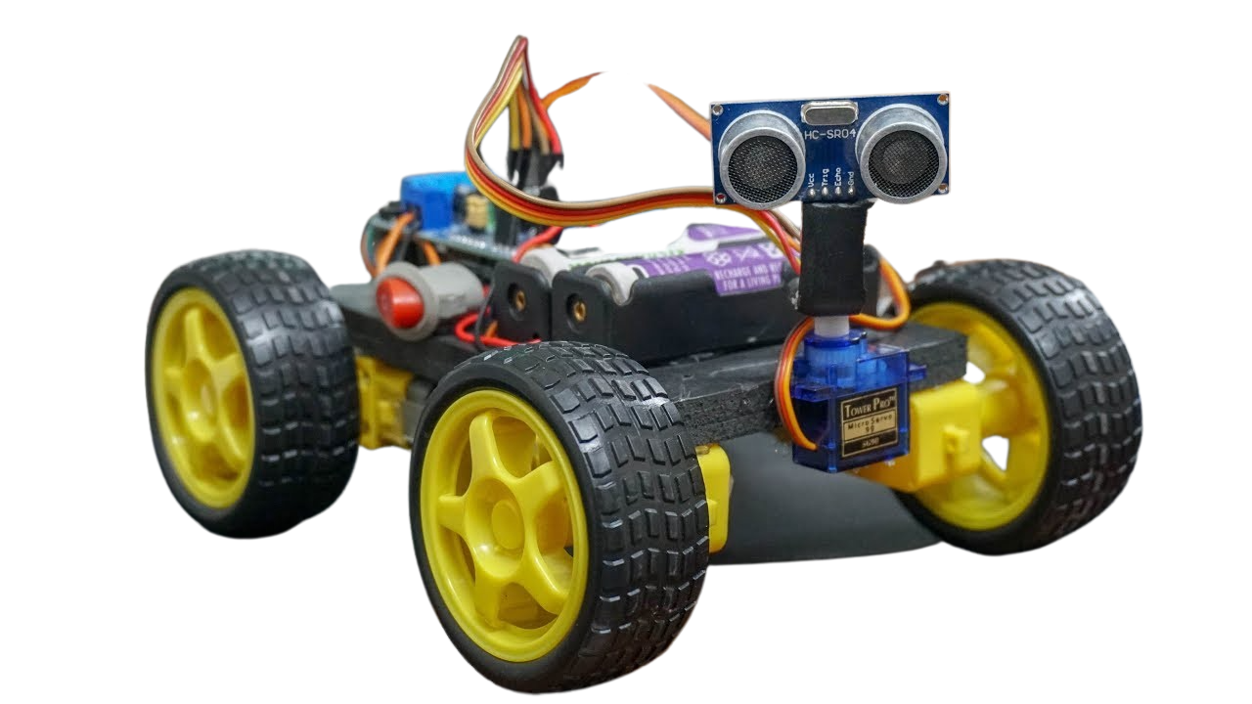
- As of the testing stage it has not any impacts on the environment nor the team or even the victims, but it has a huge risk of failure if the car has not undergone a perfect testing phase.

- Goals/Objectives
- made a frame with the best size but and the height may be addressable
- we bought a wheel with huge tire areas
- the main power source for the DC motors was the 12V batteries and a power bank for the rest of the components
- The mission time span is 2 minutes, so the goal is to collect all the data possible within the time limit

- Procedures/Scope of Work
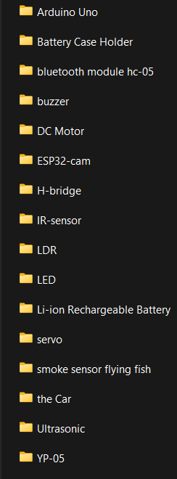
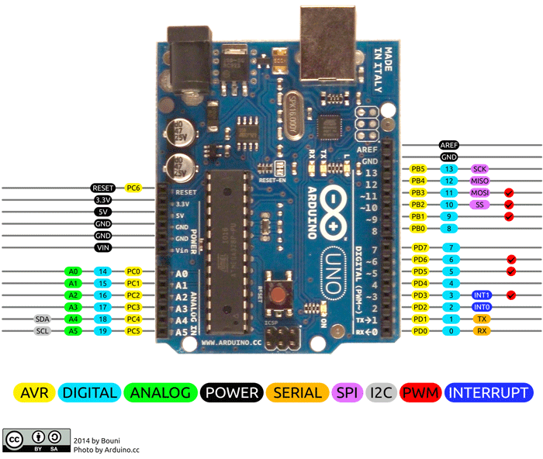
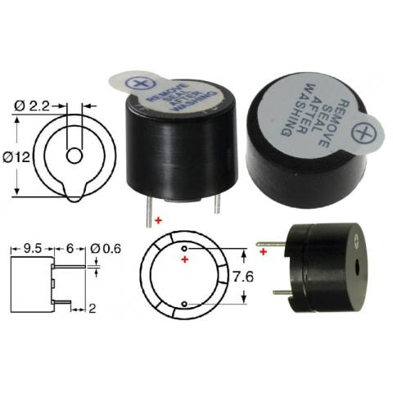
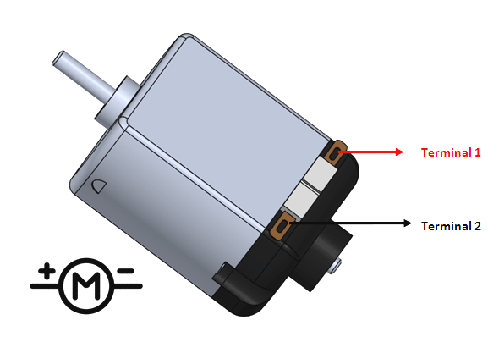
First introducing the main components:
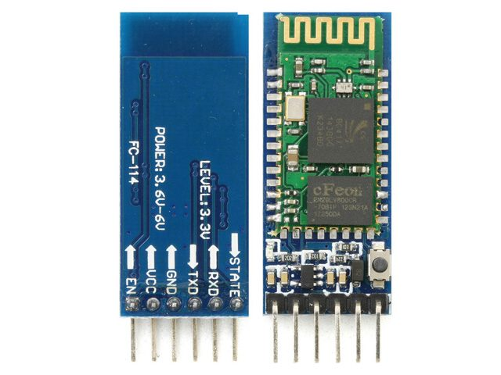

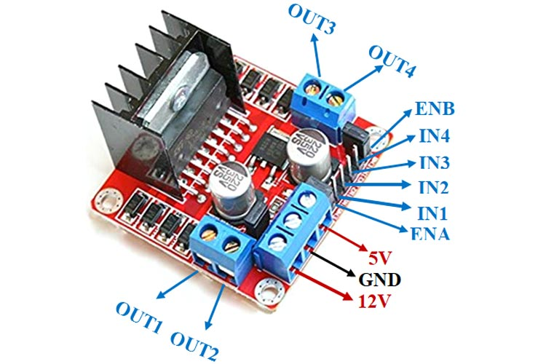
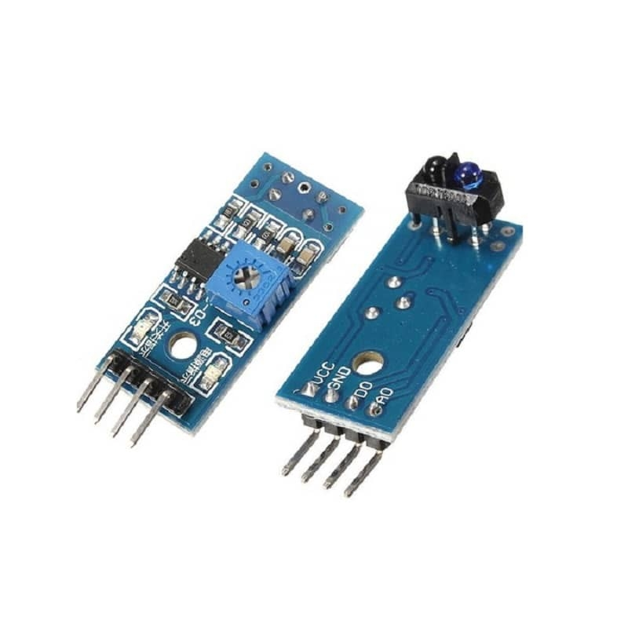
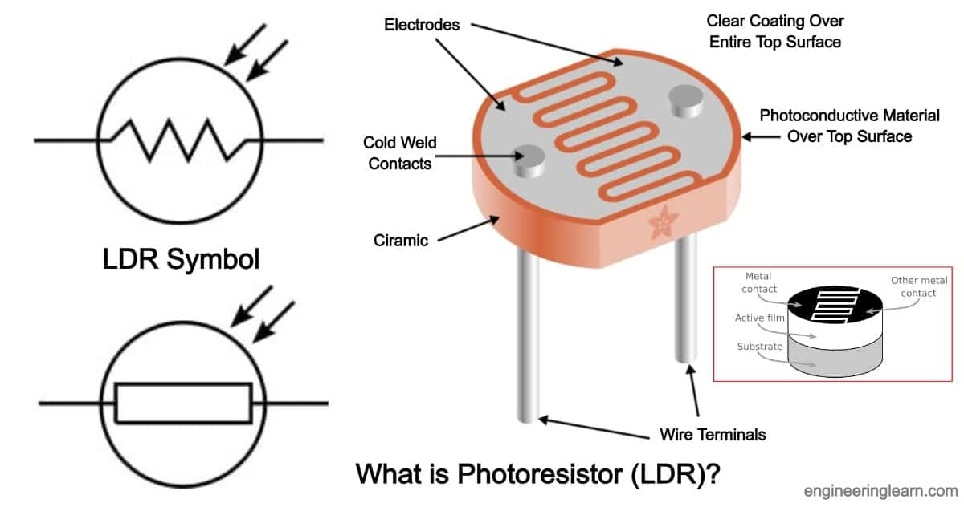

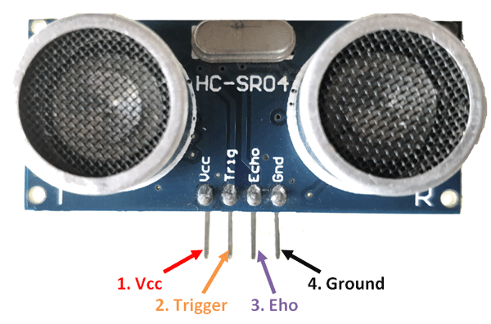
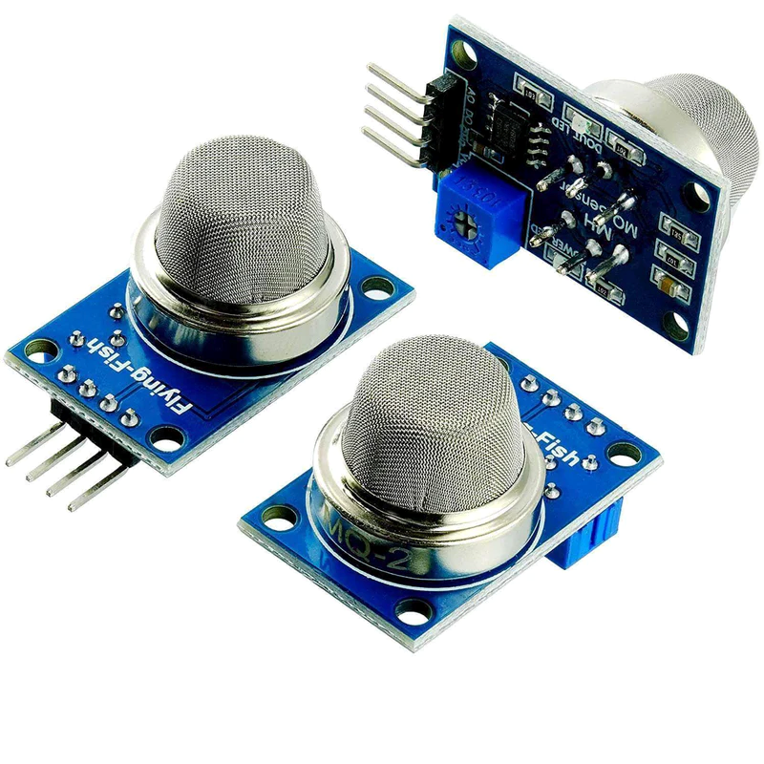
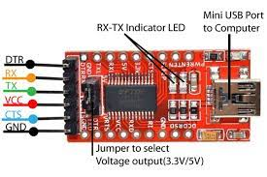

- Pre-Deployment Preparations:
  - Verify the functionality of the RC car, sensors, and Arduino components.
  - Connect the power sources: a power bank for sensors and Arduino (5V) and 12V batteries for the motors.
  - Ensure proper motor and H-bridge configuration to connect two motors in parallel
- Arduino Setup:
  - Utilize two Arduinos for distinct tasks: motor control and Bluetooth communication, and sensor integration.
  - Program each Arduino, accordingly, assigning the motor control Arduino for Bluetooth communication and the other Arduino for sensor integration.

- Bluetooth Communication with PS4 Controller:
  - Configure the Bluetooth module on the motor control Arduino to establish a connection with the PS4 controller.
  - Develop a Python script to link the PS4 controller with the RC car's Bluetooth module on the same COM port.
  - Use the Python script to translate PS4 controller inputs into motor commands, enabling seamless remote control.

- Sensor Integration:
  - Connect the IR, MQ2, and LDR sensors to the dedicated sensor Arduino.
  - Program the sensor Arduino to collect data from each sensor continuously.
  - Implement logic to process sensor readings and activate LED indicators accordingly.

- Ultrasonic Sensor for Obstacle Detection:
  - Mount the ultrasonic sensors on the RC car to detect obstacles.
  - Program the sensor Arduino to monitor the ultrasonic sensor readings.
  - Implement logic to automatically stop the RC car when an obstacle is detected at a specific distance (e.g., 40cm) while moving forward or backward.

- IR Sensor for Object Detection:
  - Mount the IR sensor on the RC car to detect moving objects.
  - Program the sensor Arduino to continuously monitor the IR sensor output.
  - Implement logic to detect moving objects based on changes in the IR sensor readings and activate a yellow LED indicator.

- LDR Sensor for Light Detection:
  - Position the LDR sensor to measure ambient light.
  - Program the sensor Arduino to monitor the LDR sensor readings continuously.
  - Implement logic to determine if the ambient light level is below a certain threshold and activate a blue LED indicator accordingly.

- MQ2 Smoke Sensor for Gas Detection:
  - Install the MQ2 smoke sensor on the RC car to detect smoke or gas leakage.
  - Program the sensor Arduino to continuously monitor the MQ2 sensor output.
  - Implement logic to detect smoke or gas leakage and trigger a buzzer while activating a red LED indicator.

- Camera System:
  - Configure the ESP32-CAM module to establish a live streaming connection.
  - Connect the ESP32-CAM to the user's laptop via Wi-Fi.
  - Develop a Python script to receive the live stream from the ESP32-CAM.
  - Display the live stream on the user's laptop, capturing screenshots every 5 seconds for additional mission-related information.

- Deployment:
  - Position the RC car near the deployment area.
  - Power on the RC car, sensors, and camera system.
  - Use the PS4 controller to remotely maneuver the RC car and assess the environment.
  - Monitor the sensor data, analyze the live stream, and review the captured screenshots for comprehensive information during the mission.
- Data Collection and Analysis:
  - Collect sensor data, including ultrasonic readings, IR sensor outputs, LDR sensor readings, and MQ2 sensor data.
  - Analyze the collected data, live stream, and captured screenshots to gain insights into the environment, obstacles, light conditions, and gas/smoke levels.

- Mission Evaluation:
  - Evaluate the performance of the Rescue RC Car based on the collected data and analysis.
  - Identify potential improvements or modifications for future missions to enhance rescue operations.

Ensure the power bank is fully charged to provide continuous power to the sensors and Arduino components. Similarly, ensure the 12V batteries powering the motors have sufficient charge for prolonged operation. Match the baud rate in the Python code with the baud rate set on the Arduino's serial monitor to establish reliable communication between the components.

The Rescue RC Car offers a versatile and efficient solution for rescue operations, combining sensor integration, camera capabilities, and user control to navigate challenging environments, detect obstacles, monitor gas/smoke levels, and gather crucial mission data.

- Timetable
Provide detailed information on the expected timetable for the project. Break the project into phases, and provide a schedule for each phase.
 | Description of Work | Start and End Dates
Phase One | Building the body of the car, installing the DC motors and the H-bridge, buying and testing all the components and sensors used, determine the power source eligible for the job. | Week 10 → Week 11
Phase Two | Making the configuration required for the camera and connecting it to a specific IP address to host the stream of what the camera sees, installing all the sensors and do all the hardwiring processes. | Week 11 → Week 12
Phase Three | Making the connection of the PS4 Controller with the Bluetooth module and the connection between the Bluetooth receiver and the motors of the car, programing the 2 Arduino’s and making the soft code for the connection of the PS4 controller and finally testing | Week 12 → Week 13


- Budget
 | Description of Work | cost
Phase One | 4-wheel robot chassis *80  4 wheels * 15  4 DC motor *35  1 battery case *18  1 small breadboard *20  1 H-bridge *65  3 Li-on Rechargeable battery *45  2 Arduino uno * 500 | 1450
Phase Two | 1 ESP-cam32 *350  35 jumpers * 20  1 LDR sensor *10  1 Bluetooth module *200  1 IR sensor *35  1 smoke sensor flying fish *50  1 Buzzer 5 volt *7  2 ultrasonic * 65 | 812
Phase Three | Ps4 controller * 800 (optional)  Software * 0.00 | 800
 | Total | $ 3062.00

- Key personnel

1. Younes Ahmed - Camera System Specialist
- Background: Younes is pursuing a degree in Computer Engineering with a focus on computer vision and image processing.
- Roles and Responsibilities: He was responsible for the camera system integration, including selecting the appropriate camera module, configuring the live streaming functionality, and implementing the screenshot capture feature. Younes also contributed to the software development and system integration.
- Achievements and Contributions: Younes's expertise in computer vision, AI and camera systems played a vital role in successfully implementing the Rescue RC Car. His technical knowledge of the seamless integration of the camera system, enabling real-time streaming and image capture.

2. Mustafa Shusha - Software Engineer and System Developer
- Background: Mustafa is studying Computer Engineering with a focus on software development and system architecture.
- Roles and Responsibilities: Mustafa was responsible for the software development of the project. He wrote the code for motor control, communication with the PS4 controller, and implemented the necessary algorithms for sensor data processing. Mustafa also contributed to the overall system architecture and collaborated with Younes to integrate the camera system.
- Achievements and Contributions: Mustafa's expertise in software development and system design were essential in the successful implementation of the Rescue RC Car. His contributions to the software development ensured responsive motor control, effective sensor data processing, and seamless integration with the camera system.

3. Mahmoud Awad - Hardware and Wiring Engineer
- Background: Mahmoud is pursuing a degree in Computer Engineering with a focus on hardware design and circuitry.
- Roles and Responsibilities: Mahmoud focused on the hardware aspects of the project. He was responsible for the physical assembly of the RC car, including the integration of motors, sensors, Arduino boards, and the camera module. Mahmoud also handled the wiring and power management for the system, ensuring proper connectivity and power supply.
- Achievements and Contributions: Mahmoud expertise in hardware design and wiring were crucial in the successful implementation of the Rescue RC Car. His attention to detail and knowledge of circuitry ensured proper functionality and connectivity of the components, contributing to the overall reliability of the system.

- Evaluation
The Rescue RC Car project was an educational journey that allowed our team of computer engineering students to enhance our skills and gain practical experience in robotics and automation. Throughout the project, we achieved several significant milestones and identified both strengths and areas for improvement.

1. Achievements and Strengths:
- Sensor Integration: We successfully integrated four sensors (ultrasonic, LDR, IR, and MQ2 smoke sensor) into the RC car, enabling obstacle detection, light sensing, and smoke detection.
- Efficient Motor Control: The car's motor control system enabled precise movement and control, responding well to user commands through the PS4 controller.
- Camera System and Streaming: We implemented a camera system that provided live streaming, allowing users to see what the car sees. Our Python script captured screenshots at regular intervals, facilitating data collection.

2. Limitations and Challenges:
- Limited Sensing Range: The ultrasonic sensors had a restricted range of 40 cm, which limited the car's ability to detect objects further away.
- Sensor Calibration and Accuracy: Fine-tuning and calibrating the sensors proved challenging, requiring continuous adjustments for accurate readings.
- Power Management: Managing power for the sensors and motors was a challenge, requiring careful planning and consideration.

3. Areas for Improvement:
- Enhanced Sensing Capabilities: Exploring sensors or technologies with broader sensing ranges could improve the car's obstacle detection abilities.
- Improved Sensor Calibration: Refining the calibration process would enhance sensor accuracy and reliability.
- Power Optimization: Investigating power-saving strategies, such as energy-efficient components or power management algorithms, could improve overall efficiency and battery life.

In conclusion, the Rescue RC Car project provided us with valuable hands-on experience in designing and implementing complex systems. Despite the challenges faced, the project demonstrated our teamwork, expertise, and ability to deliver a functional end product. We gained a deeper understanding of robotics and automation, strengthened our problem-solving skills, and built a solid foundation for future projects in the field.

- Endorsement
I am pleased to endorse the Rescue RC Car project conducted by the team of computer engineering students. Their dedication, technical expertise, and collaborative efforts have resulted in an impressive achievement in the field of robotics and automation.
Throughout the project, the team successfully integrated sensors, implemented motor control, and incorporated a camera system for live streaming and data collection. Their ability to overcome challenges and deliver a functional end product demonstrates their strong problem-solving skills and commitment to excellence.
I am particularly impressed by their teamwork and division of responsibilities. Each team member played a crucial role, leveraging their strengths to contribute to the project's success. Their clear communication and coordination ensured a seamless integration of hardware, software, and sensors.
Furthermore, the team's focus on education and learning is commendable. They approached the project with enthusiasm and a thirst for knowledge. Their willingness to explore new technologies and continuously improve their work is admirable.
I wholeheartedly endorse the team's efforts in the Rescue RC Car project and recommend their work as a testament to their skills, dedication, and potential. Their project exemplifies the qualities of a successful engineering endeavor and sets a high standard for future students in the field
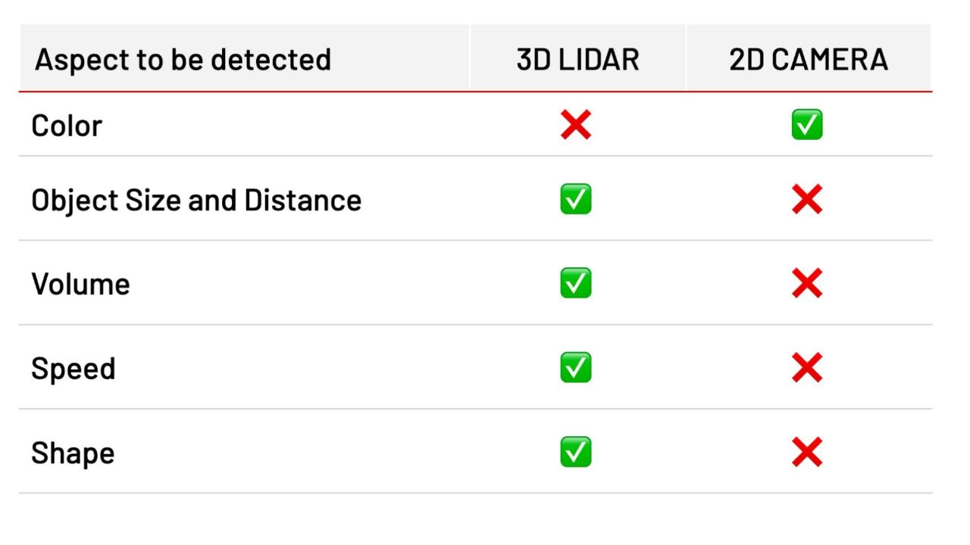
- Next Steps
- We can introduce new concepts like AI and machine learning
- New hardware components like an additional lidar used for localization
- Using a more powerful microcontroller such as raspberry pi
- Appendix
- I could not achieve any of the previous work without the help of my teachers and friends special thanks to all of them, and also cannot forget YouTube tutorials, the documentation websites of every component used in the project

- Arduino: Official website of Arduino https://www.arduino.cc/
- ESP32-CAM: Documentation and resources for ESP32-CAM - https://randomnerdtutorials.com/esp32-cam-video-streaming-face-recognition-arduino-ide/
- 6. MQ2 Smoke Sensor: Datasheet and information about MQ2 Smoke Sensor https://www.hackster.io/porrey/mq2-smoke-sensor-and-arduino-fcc62b
- 7. Ultrasonic Sensor: Information about Ultrasonic Sensors - https://www.arduino.cc/en/Tutorial/Ping
- LDR Sensor: LDR Sensor tutorial and information - https://www.instructables.com/Arduino-LDR-Sensor/
- IR Sensor: IR Sensor tutorial and information - https://www.electronicshub.org/arduino-ir-sensor-tutorial/
- H-Bridge: Overview of H-Bridge motor control - https://www.elprocus.com/h-bridge-motor-driver-circuit/
- PS4 Controller: Information on PS4 controller compatibility with Arduino - https://create.arduino.cc/projecthub/riyas-org/connect-ps4-controller-to-arduino-wirelessly-cc51f2
- Stack overflow - https://stackoverflow.com/questions/67693739/how-to-solve-this-error-in-arduino-code-esp32-board-ps4-controller

